USER Control Parameters

Create a new user
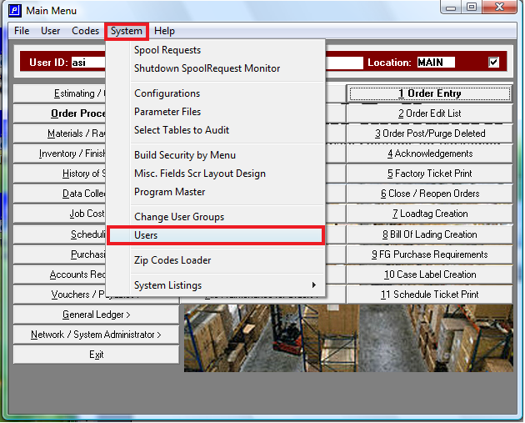

Click view user
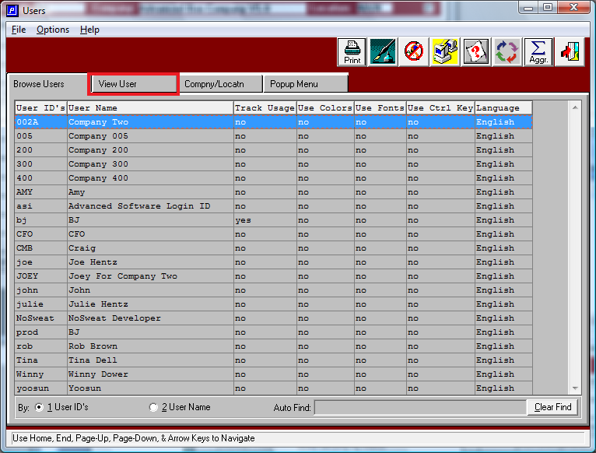

Click Add
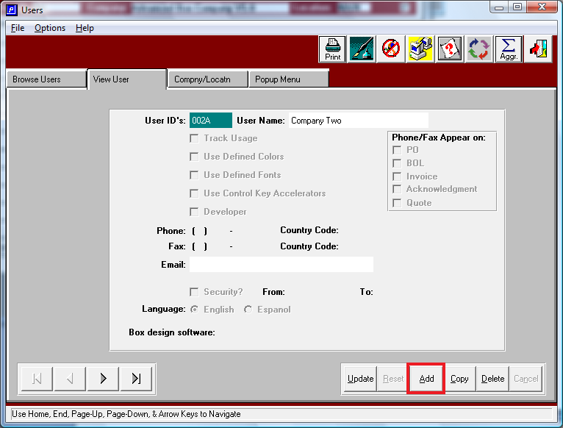

Enter in the USER ID and the user name. You can also add any of the other information such as Phone, Fax, Email. Leave all of the rest the way it is.
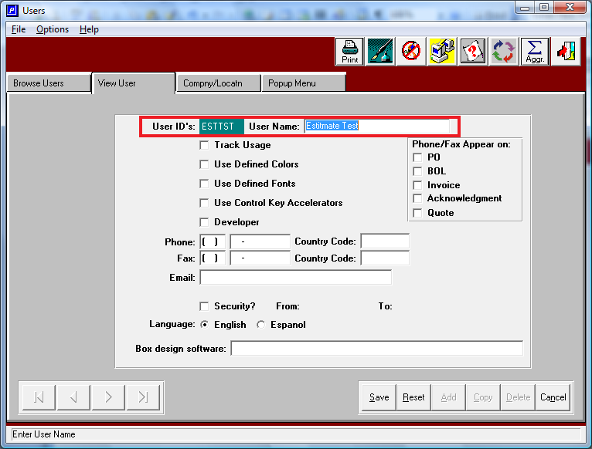

Hit Save and then you will have a box popup to enter this new users password. Please enter the password and hit enter.
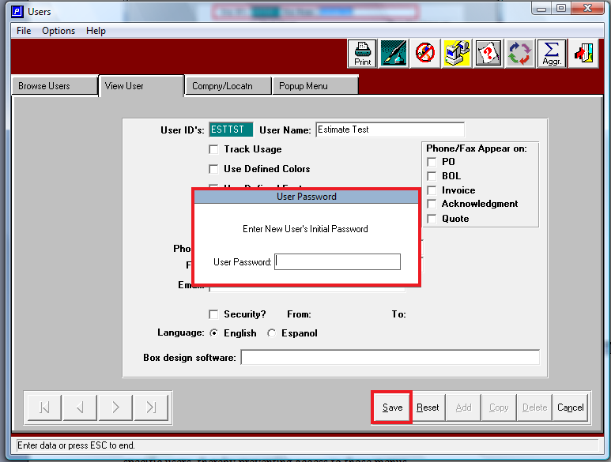
You may then hit F12 to get out of this window and go back to the main menu.

The users menu structure allows the administrator to eliminate menu options from specific users, thereby preventing access to those menus.

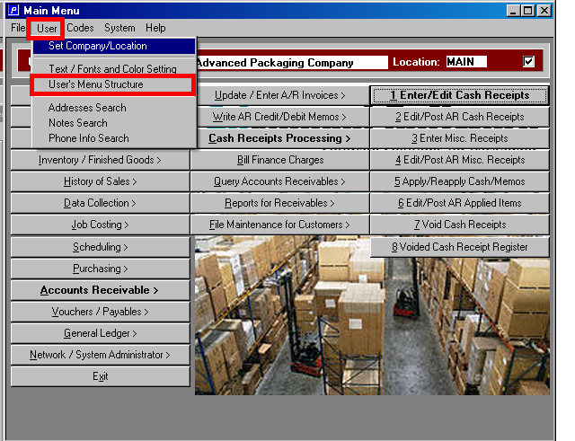

You will hit the down arrow to drop down the list of users, click on the new one you just created (ex. ESTTST).
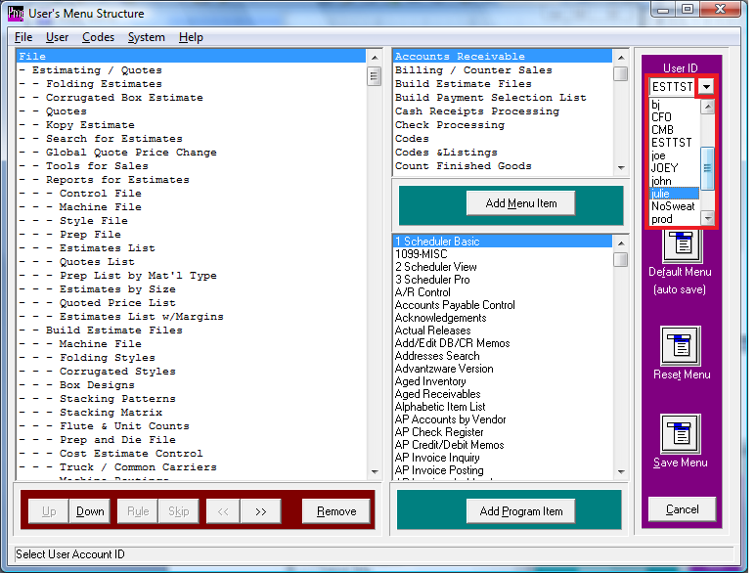

Find and click on –Materials / Raw Goods
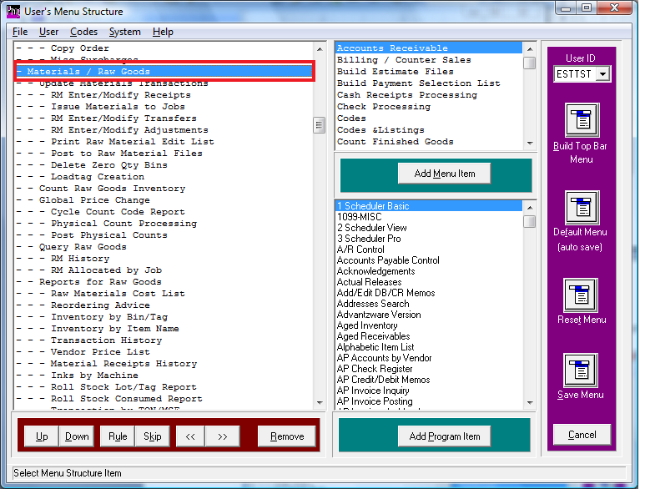

Use the down arrow to find – Order Processing and click on it.
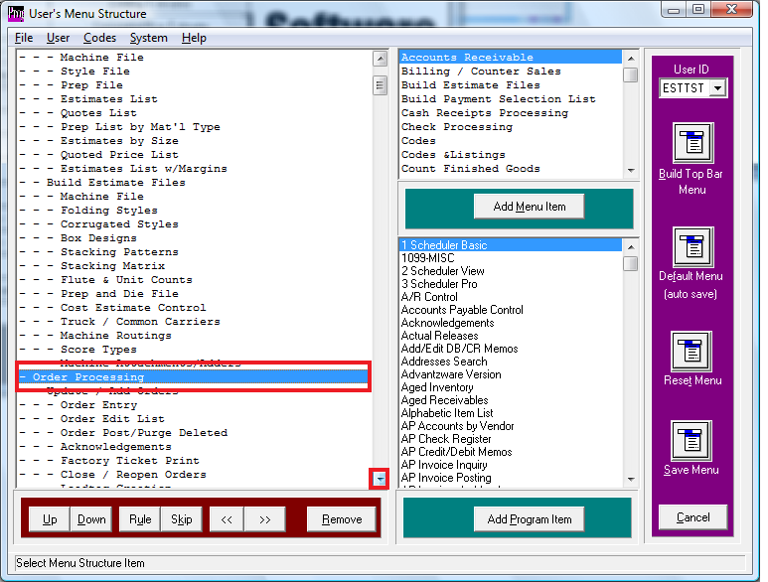

Continue to hit the remove button until you get to - - - Batch Running Procedure and then erase that one so that the next one showing is – RULE.
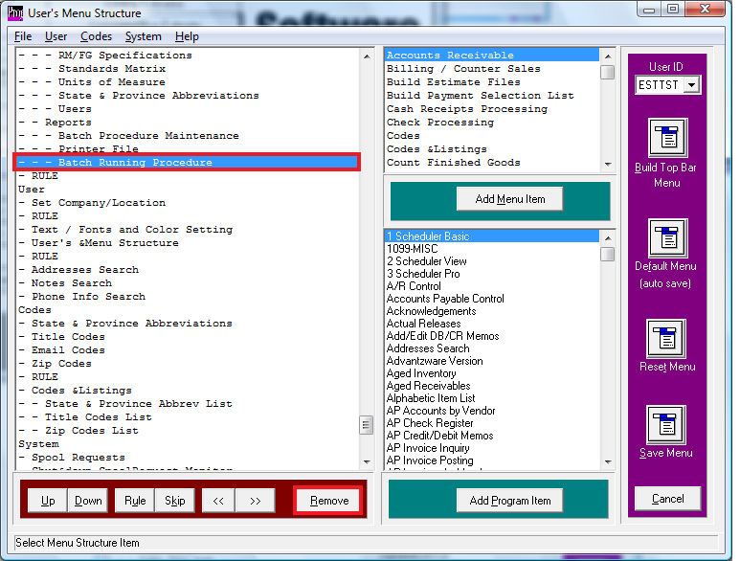

After you have removed all of this then hit the Save Menu button on the bottom right. Then you can close this window by hitting the X in the top right of the window.
